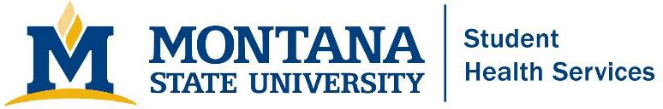
950 W Grant St | P.O. Box 173260 Bozeman, MT 59717-3180
Montana.edu/wellness/student-health-services
(p) 406-994-2311 | (f) 406-994-2504
(e-mail) immune@montana.edu

AFFIDAVIT OF EXEMPTION ON RELIGIOUS GROUNDS FROM MONTANA SCHOOL IMMUNIZATION LAWS AND RULES
Student’s full name Student ID # Date of Birth Age
I, the undersigned, swear or affirm that immunization against measles, mumps and rubella is contrary to my religious tenets and practices.

I understand that:
- I am subject to the penalty for false swearing if I falsely claim a religious exemption. A fine of up to $500, 6 months in jail, or both. (Sec. 45-7-202, MCA).
- I understand that under Montana law (MCA 50-2-118, MCA 20-5-405, and ARM 37.114.715 and ARM 37.114.716), the local health officer may exclude me from school and school-based activities when there is good cause to believe I have been exposed to, or may transmit, a communicable disease, including while awaiting test results to confirm or rule out infection. This authority applies to any of the listed diseases in ARM
34.114. Exclusion will continue until I am no longer considered at risk for contracting or transmitting the disease.
- No refund of tuition will be granted to me for missed classes.
- I must comply with Montana State University’s requirement of a tuberculosis screening form. If, according to the screening form, I need to update my TB test, it must be done within the past one year before the first day of classes.

Signature Date

- Students younger than 18 years of age are authorized to sign and submit a religious exemption on behalf of themselves.
- Any exemption signed by a parent or legal guardian for a student under 18 years of age will require resubmission with the student's signature upon the student's 18th birthday.

