
Created by the University of Minnesota to support development of high-quality open textbooks in various subjects, peer-reviewed and diverse content. http://open.umn.edu/opentextbooks

Where to Find Open Education Resource (OER) Textbooks

The next generation of open-access texts, with options for audio formats, interactive and 3D ancillary materials, and even textbook conversion to Spanish. https://libretexts.org

Listing of university press and other institutional publishing across North America. https://pressbooks.directory

Open textbooks for the 40 highest enrolled first- and second-year subject areas in the British Columbia's public, post-secondary system. https://open.bccampus.ca

Initiated by Rice University, their free textbooks are developed and peer-reviewed to ensure they meet the scope and sequence requirements of college courses. https://openstax.org
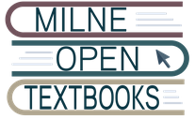
With the initiative of the SUNY Libraries, Milne Open Textbooks publishes high-quality, peer-reviewed textbooks for use in higher education. https://milneopentextbooks.org

