2026 Internships (Paid)
Greater Yellowstone Inventory & Monitoring Network
National Park Service

This is a paid internship offered through MSU’s Institute on Ecosystems ($16/hour).

Position Description: This internship conducts natural resource fieldwork with science professionals from the National Park Service’s Greater Yellowstone Network (GRYN).

Overview: Interns will assist National Park Service scientists with natural resource fieldwork across the Greater Yellowstone Ecosystem, predominantly in Yellowstone and Grand Teton National Parks and Bighorn Canyon National Recreation Area. Work supports long-term monitoring programs in upland vegetation, amphibians and wetlands, water quality, and whitebark pine. Specific program monitoring depend on intern experience and program needs.

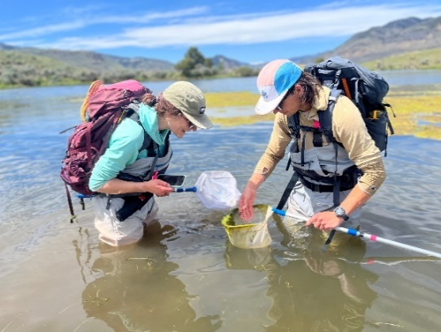
Fieldwork Details:
- Interns will collect data using established scientific protocols.
- Interns work 10–12 hour days in 2–8 day work trips involving long drives, camping in campgrounds and backcountry campsites.
- Days often include off-trail hiking 8–20 miles with a 30-50lb pack in rugged, mountainous terrain and/or many hours in chest waders.
- Fieldwork occurs in grizzly bear country and in varied weather (snow to 100°F), with biting insects (flies and mosquitoes)

Requirements:
- Interest in biological sciences and outdoor fieldwork.
- Physical ability to hike long distances off-trail at high elevations.
- Ability to work professionally and supportively in a team.
- Comfortable camping in remote areas for several days and working outside all day.
- Basic first aid/CPR training is preferred; training will be provided if needed.
- After orientation, interns should be comfortable travelling off trail and navigating using a GPS, maps, and compass.
- The intern is expected to actively participate in fieldwork to meet project goals, be inquisative, and proactive.
- Self-sufficient in backcountry and frontcountry environments or willing to learn and practice good backcountry skills.
- Professionally represent the National Park Service and Montana State University.

Logistics:
- Field gear (tents, sleeping bags, sleeping pads, cookware, bear spray, waders, etc.) is provided.
- Interns supply personal clothing, backpack, and food.
- $40 per diem food stipend for overnight trips and up to $100 stipend to purchase good hiking boots.
- Interns must attend orientation and safety training in late May
- Internship runs late May through early August.
- Full commitment and scheduling flexibility are required.
- Crews will depart for work trips from Bozeman, MT. Housing is not provided when not on a work trip.

To Apply:
Applicants should send a letter of interest, resume, and contact information for three references by 01/28/2026 to: jana_cram@nps.gov. Resumes received after that time will be reviewed on an as-needed basis. Please contact Jana with any questions.

